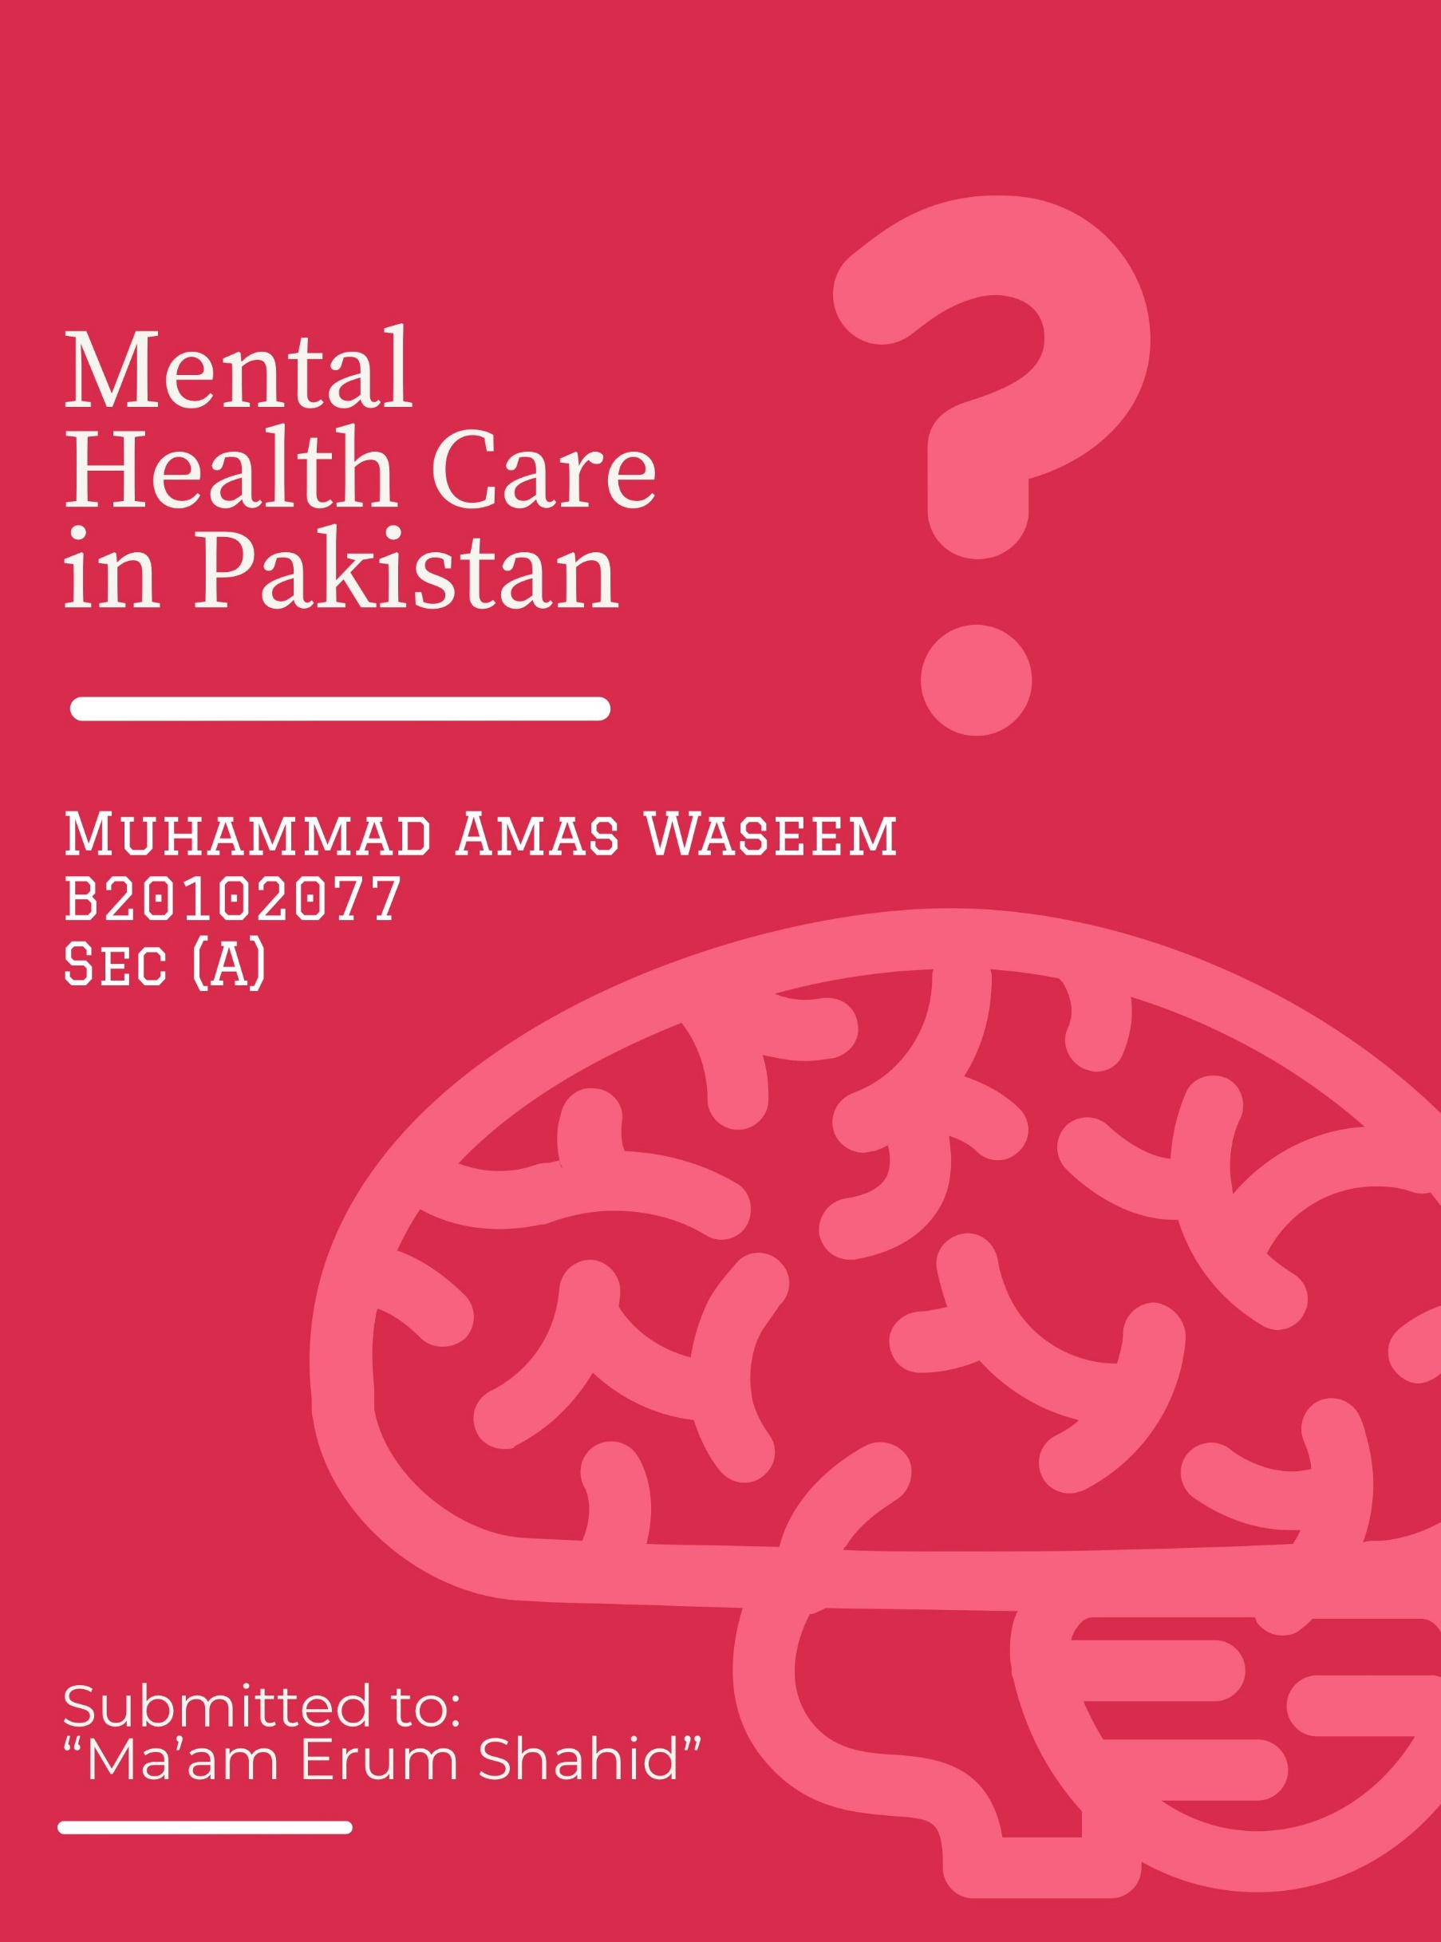

**INDEX**

1. **INCEPTION** 1
2. **DISEASE BURDEN OF MENTAL HEALTH 2**
3. **CONTEMPORARY PROGRAMS** 3

* [MENTAL HEALTH GAP ACTION PROGRAM](https://www.who.int/mental_health/mhgap/en/) (mhGAP)
* BRITISH BASIC NEED PROGRAM (BBNP)
* PAKISTAN PSYCHIATRY SOCIETY (PPS)

1. **CHALLENGES AND NECESSARY ACTIONS** 4
2. **REFERENCES** 5

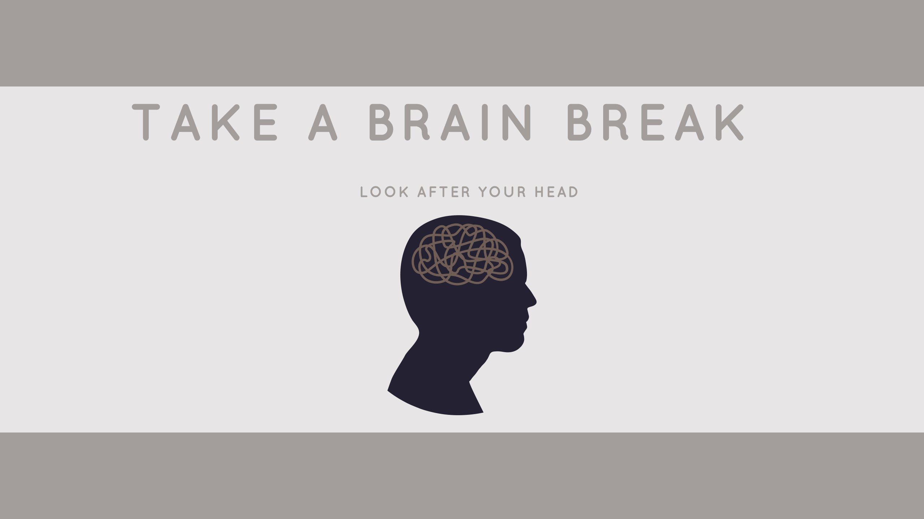

**INCEPTION:**

### Percentage of DALYS of Common Mental Disorders Pakistan

|  |  |
| --- | --- |
| **MENTAL DISORDERS** | **DALYS** |
| Schizophrenia | 0.36% |
| Alcohol use disorders | 0.47% |
| Drug use disorders | 0.70% |
| Depressive Disorders | 1.28% |
| Bipolar disorders | 0.27% |
| Anxiety disorders | 0.89% |
| Eating disorders | 0.06% |
| Autistic Spectrum | 0.33% |
| ADHD | 0.01% |
| Conduct disorder | 0.26% |
| Intellectual Disability | 0.21% |
| Other mental disorders. | 0.32% |

Mental health is the most neglected field in Pakistan where 10- 16% of the population, more than 14 million, suffers from mild to moderate psychiatric illness. The allocated mental health budget is 0.4% of total health care expenditures. Estimated mental health spending per capita is (US$) $0.01. There are only 5 mental hospitals in Pakistan.

Several Mental health outpatient facilities are 4,356 and the number of mental health day-treatment facilities is 14. There are 18 NGOs in the country involved in individual assistance activities such as counseling, housing, or support groups. Of these, 45% work for government-run mental health facilities and 51% work with non-governmental organizations and other private institutions, while 4% work in both sectors.

**DISEASE BURDEN OF MENTAL HEALTH:**

The burden of mental disorders in terms of [Disability-adjusted life years](https://en.wikipedia.org/wiki/Disability-adjusted_life_year) (per 100,000 population) is 2,430. Common mental health problems have been identified in both the rural and urban population which seems to have a positive association with [socioeconomic adversities](https://en.wikipedia.org/wiki/Socioeconomic_status), relationship problems, and lack of [social support](https://en.wikipedia.org/wiki/Social_support). [Depressive](https://en.wikipedia.org/wiki/Depressive_personality_disorder) and [anxiety disorders](https://en.wikipedia.org/wiki/Anxiety_disorder) appear to be highest, followed by [bipolar disorder](https://en.wikipedia.org/wiki/Bipolar_disorder), [schizophrenia](https://en.wikipedia.org/wiki/Schizophrenia), [psychosomatic disorders](https://en.wikipedia.org/wiki/Psychosomatic_disorders), [obsessive-compulsive](https://en.wikipedia.org/wiki/Obsessive%E2%80%93compulsive_disorder), and [post-traumatic stress disorder](https://en.wikipedia.org/wiki/Posttraumatic_stress_disorder).

[Depression](https://en.wikipedia.org/wiki/Major_depressive_disorder) often starts at a young age and affects women more commonly than men. One or two mothers out of 10 have depression after childbirth. Depression also limits a mother's capacity to care for her child, and can seriously affect the child's growth and development. Pakistan is one of those countries where the mental health of children is not taken seriously by parents. As per recent stats published by one news website, almost 36% of people in Pakistan are suffering from anxiety and depression.

The major reason for these mental illnesses is a bad relationship with friends & family. Moreover, due to the recent pandemic, poverty and unemployment also increase the depression, anxiety, and suicide rate.

Almost 18,000 people in Pakistan commit suicide annually while the number of [suicide](https://en.wikipedia.org/wiki/Suicide) attempts is almost four times greater than these figures. Suicide prevalence in Pakistan is 9.3 people per 100,000 persons.

**CONTEMPORARY PROGRAMS:**

Several innovative programs to develop indigenous models of care like the 'Community Mental Health Program' and 'Schools Mental Health Program' have been developed by the Pakistan government. These programs have been found effective in reducing stigma and increasing awareness of mental illness amongst adults and children living in rural areas.

[**MENTAL HEALTH GAP ACTION PROGRAM**](https://www.who.int/mental_health/mhgap/en/) **(mhGAP):**

Recently, [WHO](https://en.wikipedia.org/wiki/World_Health_Organization) launched a “[mental health Gap Action Program](https://www.who.int/mental_health/mhgap/en/)” (mhGAP). It will call for improving political commitments and help develop policies, and legislative infrastructure, to provide integrated health care.

**BRITISH BASIC NEED PROGRAM (BBNP):**

The [British Basic Needs](http://www.basicneeds.org/strengthening-mental-health-services-in-pakistan/) program, a mental health-focused international NGO with a global reach spanning 14 countries, began forming partnerships with Pakistani nonprofits in 2013, has already served 12,000 people in need of psychiatric attention. In addition to setting up camps where patients can see doctors, receive prescriptions for medicines and engage in therapy, the program trains citizens to recognize symptoms and side effects of mental illnesses.

**PAKISTAN PSYCHIATRY SOCIETY (PPS):**

Society is also committed to promoting excellence in the field of psychiatry, providing the best clinical practice based on recent advancements and recommended guidelines, to assist in the prevention of mental illness and to reduce the stigma associated with psychiatric illness. It seeks to advance the profession of psychiatry at both national and international levels.

The PPS regularly organizes public awareness programs, promotes research, and publishes scientific journals, bulletins, and magazines on mental health issues. It continues to work under its vision of promoting mental health, providing ethically sound care for patients, and maintaining professionalism in the field of psychiatry.

**CHALLENGES AND NECESSARY ACTIONS:**

The stigma against mental illness is rampant in Pakistan. It is sustained by a popular belief in spiritual cures — exorcising evil spirits, experimenting with herbal cures — and a lack of awareness about mental illnesses' causes, symptoms, and cures. Even when patients recognize their symptoms, overcome the stigma, gain the support of their families and start looking for medical help, there are insufficient mental healthcare facilities.

It is concluded that the health care system's response in Pakistan is not adequate to meet the current challenges and that policy changes are needed. Mental health care needs to be incorporated as a core service in primary care and supported by specialist services. Political commitment, adequate human and financial resources, and advocacy are needed for the integration of mental health into [PHC](https://en.wikipedia.org/wiki/Primary_healthcare) in Pakistan.

There is a strong need to provide adequate training for general practitioners and postgraduate training for mental health professionals to meet the current demands. A collaborative network between stakeholders in the public and private sector, as well as [non-governmental organizations](https://en.wikipedia.org/wiki/Non-governmental_organization), is required that promotes mental health care and advocates for changes in mental health policy.

**REFERENCES:**

1. <https://www.thelancet.com/journals/lanpsy/article/PIIS2215-0366(18)30191-3/fulltext>.
2. <https://www.cambridge.org/core/journals/bjpsych-international/article/mental-health-law-in-pakistan/92791134964FDEAA7FC6DAC02CAD6543>.
3. <https://www.thequint.com/voices/blogs/mental-health-crisis-in-pakistan>
4. <https://www.thenews.com.pk/latest/156099-50-million-people-with-mental-disorders-in-Pakistan>
5. <https://www.who.int/mental_health/pakistan_who_aims_report.pdf>
6. <https://onlinelibrary.wiley.com/doi/10.1111/j.1365-2214.2004.00382.x>
7. "Disturbing facts about mental health in Pakistan | Political Economy | thenews.com.pk". www.thenews.com.pk. Retrieved 2020-11-11.
8. <https://en.dailypakistan.com.pk/21-Jun-2017/world-health-day-promoting-mental-health-in-global-development-agenda>
9. <https://ppspk.com/>
10. <https://www.thelancet.com/journals/lancet/article/PIIS0140-6736(19)32979-4/fulltext>